Finance Project

By

Name

December 2021

SECTION 1 – INTRODUCTION

Understanding the background of a company is crucial for analysts to analyze various financial aspects of the company. This paper seeks to have a deeper look at the Facebook corporation by analysing its basic organizational structure, how they do business, and the challenges that the company faces in the process of delivering its services. The paper also seeks to do a deeper analysis of the profitability of the company, analyze its risks, assess its accounting quality, financial forecast as well as analyze its valuation. Facebook is a company that operates as a social networking company globally. Facebook develops social networking applications that aim in connecting people through the use of mobile and computer devices. The users can share ideas, opinions, and even other activities online. the company belongs to S&P 500 index meaning it’s among the largest United States companies as measured by market capitalization (Pompili & Tutino, 2019). Major competitors of the company are all companies that offer regional social networks, traditional and mobile businesses that provide marketing services to their audience, companies that develop and deliver virtual reality products as well as consumer hardware, etc. The company has been performing so well in recent years which has enabled them to grow its capital base. This growth has enabled the company to acquire other social networking companies like Instagram and WhatsApp.
How the company organizes itself.
Facebook has various business units which work together for the common goal in the company. These business units include the accounting unit, human resource unit, operations, marketing, and sales unit. The company is headed by a board of directors chaired by the founder Mark Zuckerberg. The company has also been able to extend its services globally with Facebook and WhatsApp being the most widely used application in the world.
Macro-economic factors impacting the company.
Employment
From when the company was established, the company has experienced exponential growth characterized by increased returns on its investments. This growth has made the company expand its workforce by employing more employees to meet the company's demands. Actually, as of March 31, 2021, the total number of employees in Facebook stood at 60,654 as compared to the last 10 years in 2011 where the total number of employees was 3,200 employees meaning the company has greatly grown.
Inflation
Economically the change in currency prices affects business financial standings significantly. Facebook is not an exception from inflation. When covid 19 stroke the world there has been changes in currency prices all over the world and this inflation has also been impaction the company returns in the long run.
Regulatory environments
Remember, the main aim of Facebook was to create a social network platform. The government however came up with regulations that have been in place some of which have restricted the company from achieving maximum social network targets. These restrictions are extended to different governments of the world with some countries setting very tough rules based on protecting their citizens' privacy. This has made it hard for Facebook to thrive smoothly in some countries.

SECTION 2 – PROFITABILITY ANALYSIS

Capital structure analysis
In simple terms, Capital structure analysis refers to a periodic evaluation of all components of equity and debt used to finance a business. The key aim for us is to evaluate the combination of equity and debts that Facebook has at the moment by looking at the impact that capital structure might have on the equity to debt ratio.
First, from Facebook's financial statements and standings the company has been doing pretty well which implies that there have been not many difficulties in financial circumstances. This implies that the company has been in a position to restructure its operations to improve its profitability. Further, there has been no trenches of debt to be paid down which has made it possible for the company to channel its available cash investments that seek to maximize the company profits (Bilgin & Dinc, 2019). Lastly, the company has been able to achieve a better rating for their bonds which has enabled them to restructure their financing mix thereby making their bonds more conservative which in the long run improves all the available odds of investors being repaid for the purchases of the company bonds.
Common size analysis in Facebook
Common size analysis refers to the use of financial tools to analyze financial statements by normalizing on expressing each line item as a percentage of a given base amount in a certain period. See appendix 2

Returns on Assets (ROA) in Facebook
Return on assets refers to the comparison of the value of the business assets with profits made within a certain period. It’s a financial tool used by financial analysts to showcase how effective a company is using its resource intending to make a profit. ROA is a good metric for gauging returns on the assets as well as showing company performance in a certain period (Pointer & Khoi, 2019). The figure in the Appendix shows Facebook Returns on Asset as compared to other world giant Tech companies. See Appendix
Return on common Equity
The return on common equity ratio can be defined as the measure of how much money typical shareholders get from a given company compared to what they originally invested. Facebook shares have been doing so well on the security exchange for the last ten years. This implies that the return on the common equity to the shareholders has also been high since the return on common equity depends on the parameters revolving around security exchange. If the company is well-rated, it’s again for the shareholders.
Relationship between ROE and ROCE
Return on assets (ROA), is mainly focused on the efficient utilization of assets while ROCE, on the other hand, is concerned with comparing companies’ capital-intensive units or the companies that have large debt loads. This difference forms the disaggregation viewpoint of ROA and ROCE.

SECTION 3 – RISK ANALYSIS
Major sources and nature of risk
Competition
One of the major sources of risk in Facebook is the competition the company faces from the world giant companies. Companies like Google, YouTube, and Apple pose the greatest risk to the company. Further, 85% of the total revenue in Facebook comes from advertisements this means that the company needs to rebrand itself from time to time so that it can retain its esteemed customers.
Global expansion
Unlike other Facebook competitors, some countries have rejected Facebook to be established in their countries. Countries like North Korea have very strict laws regarding social media (Srinivasan, 2019). This has greatly impacted the Facebook targeted social network creation which in the long run implicate lower return.
Regulatory uncertainties
Many worlds government come up with regulations that tend to restrict their citizens from accessing Facebook. In some countries, some regulations limit students from accessing social networks on the basis that Facebook has been one of the causes of cyberbullying. This in return poses a threat of Facebook being overtaken by other companies.
Gauge On Facebook financial flexibility
In simple economic language financial flexibility refers to the ability of a company to have quick access to new funds to meet main business needs that arise unexpectedly either as an investment opportunity or a big business crisis. Alluding to Facebook's financial standing, we noted that the company has not been experiencing financial difficulties as they have had positive growth for the last 20 years. The rise in Facebook price share is also an indication that the company stock price is very stable which also insinuates that the company has had financial flexibility. Further, the company acquired WhatsApp and Instagram without opting to get loans from financial institutions. This is a clear indication that the company was financially flexible.
Analysis on short term liquidity risk
Liquidity risk in finance means how easily security or an asset can be sold or bought in the market or rather how easily an asset can be converted into cash. Facebook has both preference and ordinary shares all of which have been doing well in the stock market (Ali & Limodio, 2021). The essence of having less volatile stock has enabled the company to withstand the liquidity risks for years they have been in business.
Analysis on credit risk
In finance, credit refers to the likelihood of a loss as a result of borrowers failing to meet contractual agreements’ the time Facebook has been in business the company has maintained a good credit rating (Ghenimi & Omri, 2017). From the financial statements, the company has been trying to escape instances of borrowing which have been made possible by the fact that the company has been very flexible financially. This has helped the company to evade credit risks that come as a result of failure to pay debts at the right times
The measure of systematic risks
Systematic risks refer to risks that are inherent in the entire market meaning that the risks are typically very volatile or unverifiable. To evade these risks Facebook has been ensuring that they have used the accurate asset allocation strategy or through the use of hedging techniques.

SECTION 4 – ANALYSIS OF ACCOUNTING QUALITY
Earning quality
In finance earning quality refers to the part of the income that is attributable to the key operating routines of the company. By this definition, it follows that if Facebook reported an increase in profits due to cost reduction or through sales then t could be considered that the earning quality was high (Moscariello & Fera, 2020).
Liability recognition and measurement
Economically Liabilities are normally measured by conforming with the cost criteria or principle. A liability is recognized when an obligation is initiated with the amount of liability being equal to the present market value of the loan or resource received concerning time. Facebook has been measuring its liabilities, recording and reporting them at their respective principal amount. This is the best systematic way of tracking the growth of interest on liabilities. In the long run, it makes the accounting process simple and reliable thereby uplifting the quality of the accounting process.
Asset recognition and measurement
The basic criteria used for asset recognition are based on the assumption that expenditure will end up to an economic benefit accruing to the owner in the final reporting period. Facebook has been performing asset growth through variations in the market price of its stock. This makes it easy to estimate the appreciation of the assets for a given period.
One-time items
One-time item refers to an expense, loss, or gain on the income statement of a company that is not recurring in nature. Facebook has not been considering a one-time item as a perpetual business operation. This ensures that the financial analysts can evaluate the company performance properly thereby boosting accounting quality.
Changed in policy
Change in policy in accounting refers to adjustments of accounting routines and is normally aimed at identifying business loopholes. However, a change in accounting policies might impact the business negatively because it takes time for the new management to align themselves to the new way of doing things in a company. To ensure quality in accounting.
Does financial statements quality affect valuations?
It's good to note that the two are interdependent. Quality financial statements imply accurate valuations and vice versa. A business that normalizes on providing quality accounting enjoys the benefits of having accurate valuations which in return implicates that the company can evade chances of fraud or misstatement.

APPENDIX A – APPENDIX TITLE

Appendix 1 on common size analysis.
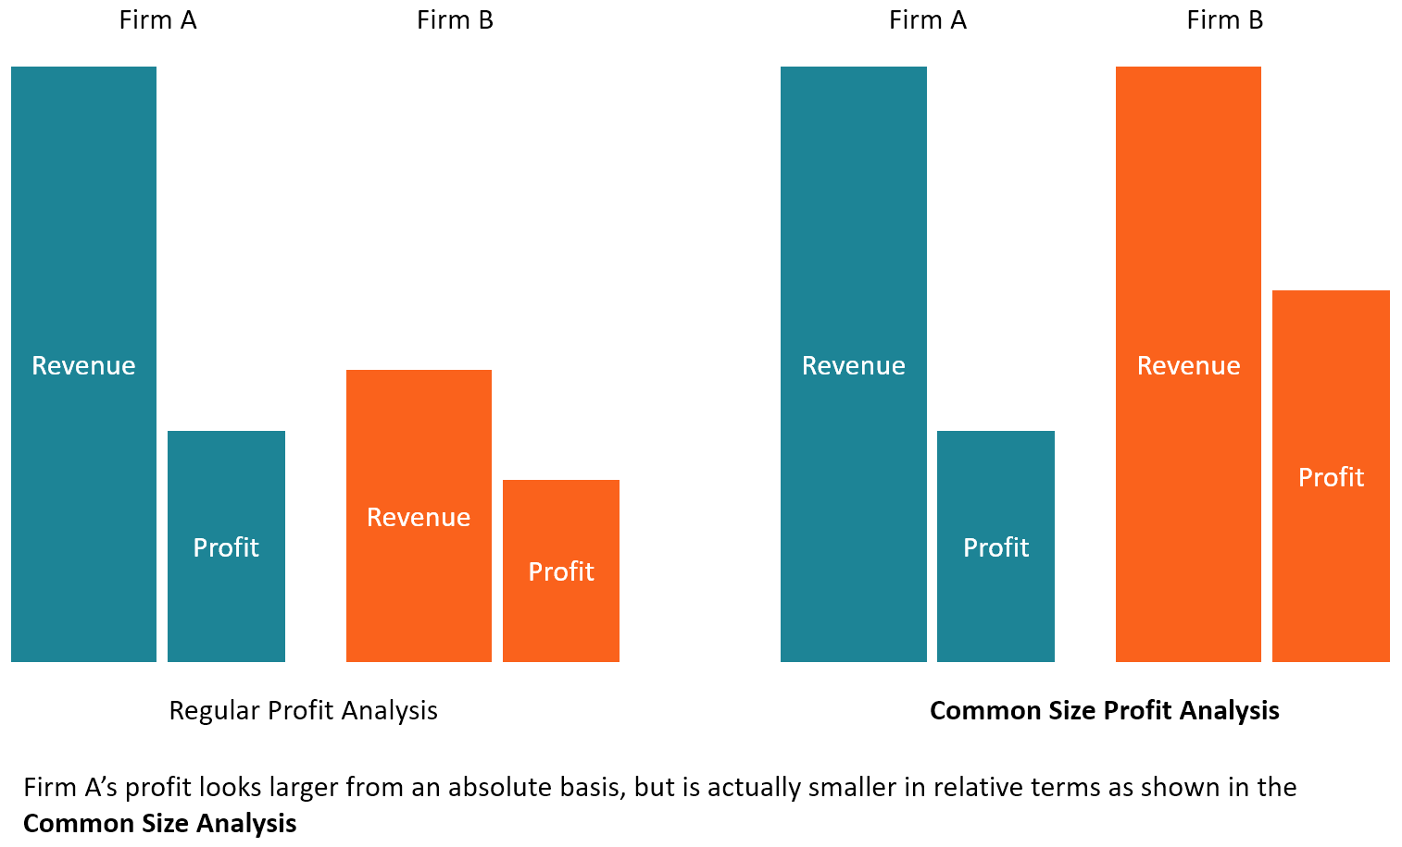

Appendix 2 on Return on Assets

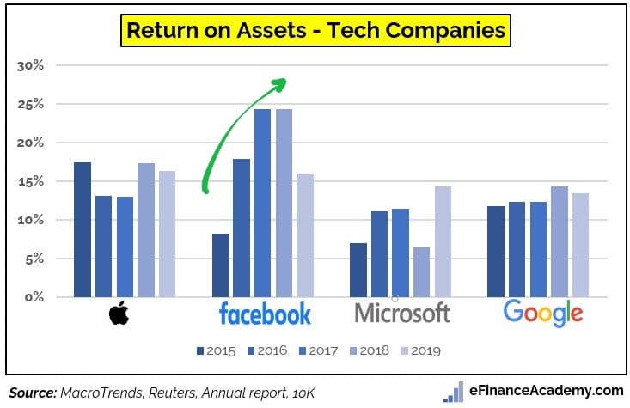

References

Ali Choudhary, M., & Limodio, N. (2021). Liquidity Risk and Long-Term Finance: Evidence from a Natural Experiment. The Review of Economic Studies.
Bilgin, R., & Dinc, Y. (2019). Factoring as a determinant of capital structure for large firms: Theoretical and empirical analysis. Borsa Istanbul Review, 19(3), 273-281.
Ghenimi, A., Chaibi, H., & Omri, M. A. B. (2017). The effects of liquidity risk and credit risk on bank stability: Evidence from the MENA region. Borsa Istanbul Review, 17(4), 238-248.
Lynch, L. J., & Coleman, A. Facebook, Inc.: A Look at Corporate Governance.
Moscariello, N., La Rosa, F., Bernini, F., & Fera, P. (2020). Revenue-expense versus asset-liability model: The impact on the earnings attributes of non-financial private firms. Meditari Accountancy Research.
Pointer, L. V., & Khoi, P. D. (2019). Predictors of return on assets and return on equity for banking and insurance companies on Vietnam stock exchange. Entrepreneurial Business and Economics Review, 7(4), 185-198.
Pompili, M., & Tutino, M. (2019). Fair value accounting and earning management: The impact of unobservable inputs on earning quality. Evidence from the US. Corporate Ownership and Control, 16(2), 8-18.
Srinivasan, D. (2019). The antitrust case against Facebook: A monopolist's journey towards pervasive surveillance in spite of consumers' preference for privacy. Berkeley Bus. LJ, 16, 39.

